18/01/2026
FEEDBACK Julius
By email

Hi Sarah,
Quick update on the setup — Phase 1 is now complete.
I’ve already created the folders used by the workflow:
- Approved → invoices processed successfully, logged, and archived
- Quarantine → invoices requiring manual review, with a clear explanation logged for each one
I’ve also created a temporary folder titled “All incoming invoices should be moved here for proper processing.”
You can rename it to whatever you prefer — the name doesn’t matter.
The only remaining step on your side is to confirm this folder as the single entry point for incoming invoices (PDFs or images).
This is not going to work for me, too much manual work for me, too many confusions between the clients or projects.
With the IA, I need to be able to target the specific file I want to work on, in this case :
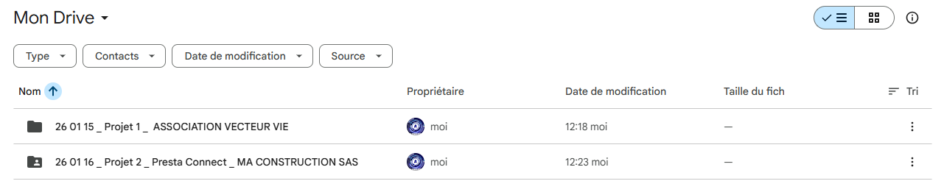
See example Manage entire google drive https://www.youtube.com/watch?v=xxoXj8Pe3qg
Why one incoming folder (instead of multiple folders):
- It avoids any manual triggering or folder switching I need an interface to target the specific file I want to work on
- It prevents invoices from being missed or processed twice it is going to mix up my mind
- It keeps the automation fully reliable and predictable not manageable for a human who have different specific folders to work on
To keep the automation working smoothly, this folder should contain only invoice files (PDFs or images) and no subfolders. In each folder directly on the Drive, I can make all the invoices without sub folders (achats et ventes)
Subfolders are not monitored at this stage, so placing invoices directly in the folder ensures they are processed automatically. It needs to be, that is the basis on IA, to manage a big amount of documents without been mixed up
Once this folder is in use, you’ll simply drop new invoices there and the workflow will automatically:
- analyze the document,
- either approve it and log the accounting entries,
- or quarantine it with a clear explanation of what went wrong.
This ensures the process is fully automated, transparent, and avoids the issues you experienced with previous tools.
Just let me know once the incoming folder is confirmed or renamed as you like.
Best,
Julius

Once each specific folder has run, the results need to go on your google drive folder, with comprehensive name each specific folder
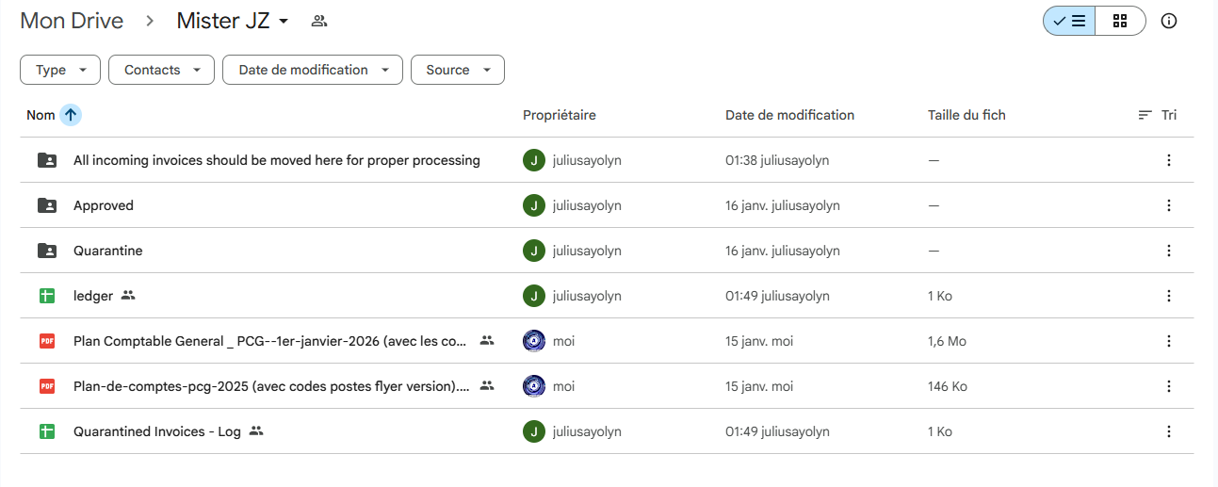
To something more organized
And have inside each one :
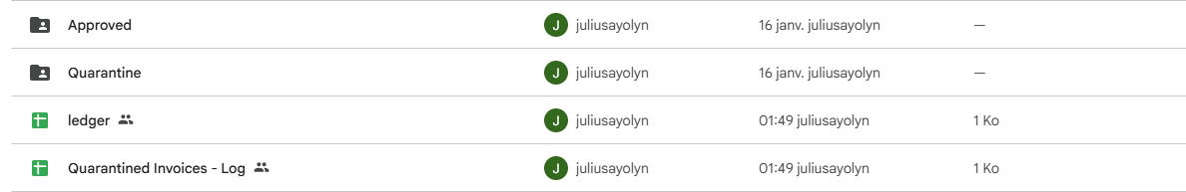
I already have to take all the invoices in paper, and take pictures, and put in pdf when there are many pages in the invoice, I cannot imagine myself taking the human risk to copy past, delete and mix client/project in an only place.
I need something that gives me the option to choose which folder I want to process, and to get the results by client/project specific folder.
Maybe a way https://relevanceai.com/docs/knowledge/integrated-knowledge-sources/google-drive

